Experiment 3
The stakeholders have conflicting views on the user interface design
for an E-Commerce mobile app. Create a prototype using Figma tool
to discuss with the stakeholders to get their feedback and approval.
Step 1. A new page is created by selecting the Frame tool in Figma and choosing the iPhone Plus layout to define the mobile screen size.
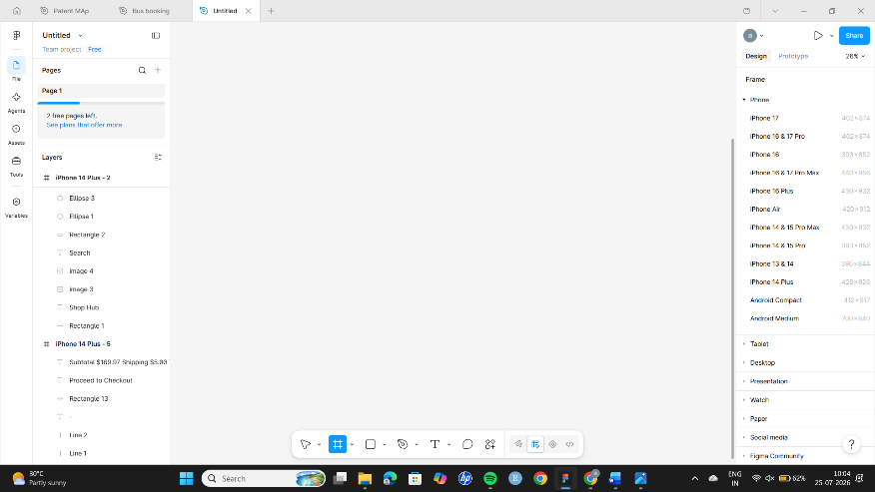
Step 2. Icons are added by downloading them from the Flaticon website and pasting them into the Figma workspace.
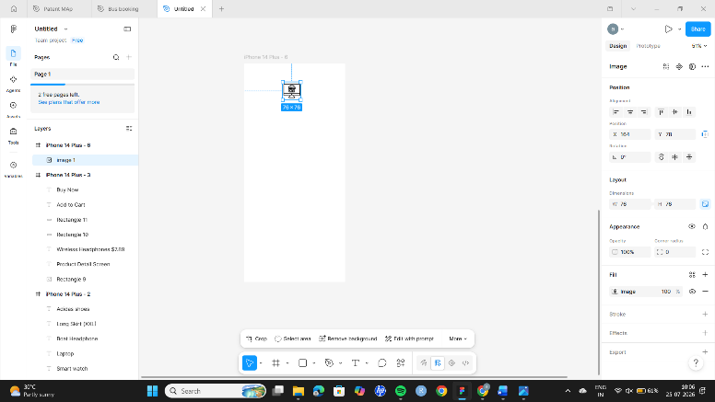
Step 3. Text elements are inserted using the Text tool (T) to include titles and labels in the design.
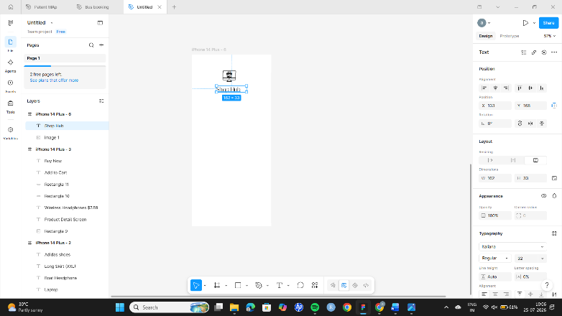

Step 4. Text styles are enhanced by changing the Typography, size, and style using the properties panel on the right side.
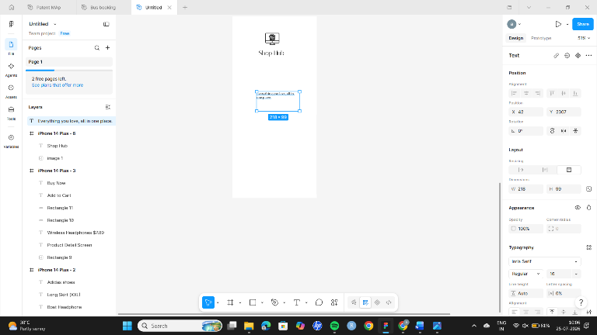
Step 5. More icons are added from external sources (Flaticon) to improve the visual appeal and usability of the interface.
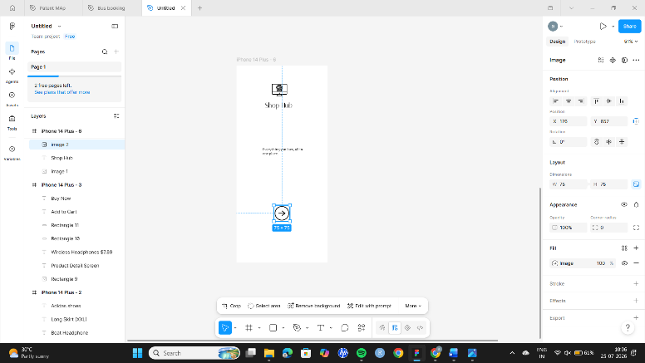
Step 6. A new frame is added to design additional screens by selecting the frame tool again.
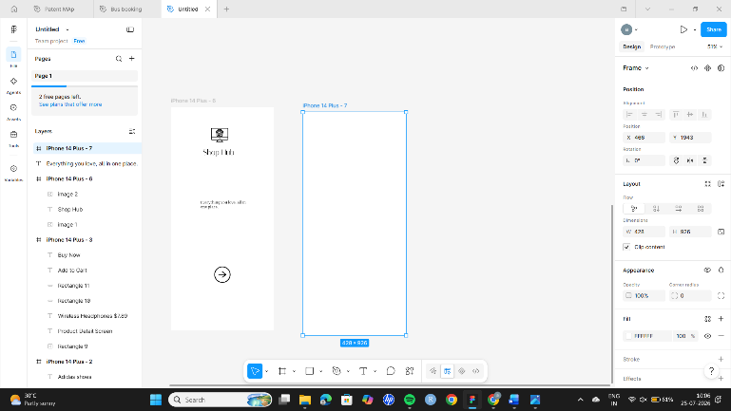

Step 7. Titles and icons are placed appropriately to structure the layout and improve navigation.
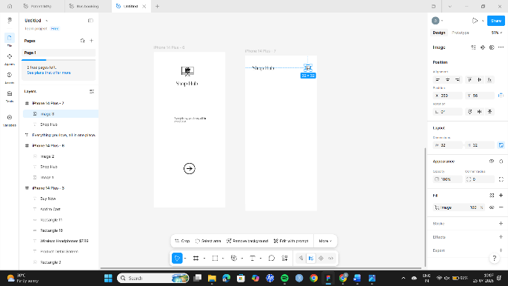

Step 8. A search bar is created using shapes and text to allow users to search for products easily.
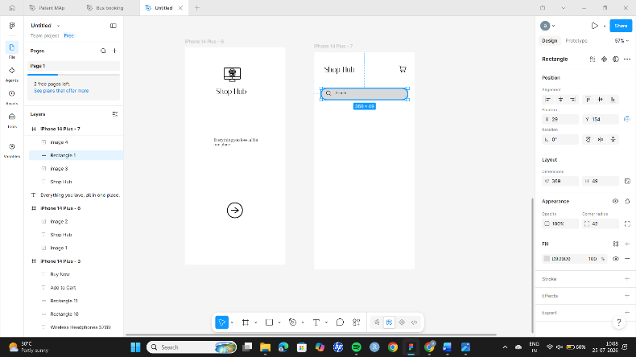
Step 9. Rectangles are added using shape tools to create sections such as product cards and containers.
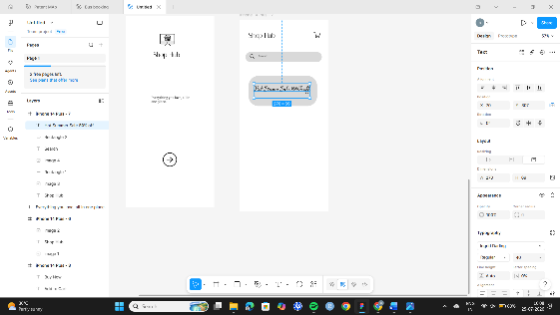
Step 10. Additional shapes and text elements are combined to build UI components like product listings.
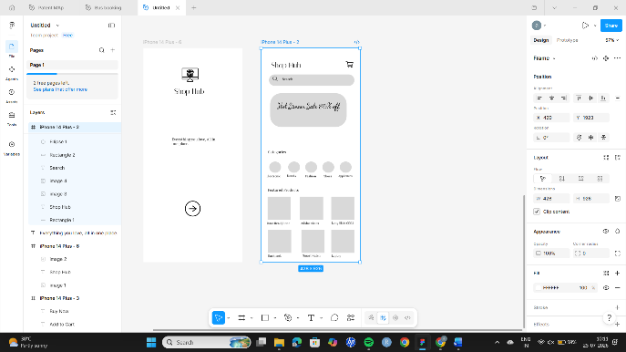

Step 11. Another mobile frame (iPhone Plus) is created to design a different screen of the application.
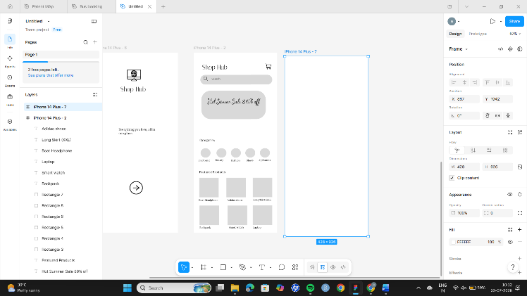
Step 12. Images are copied from external websites and pasted into the design along with relevant text.
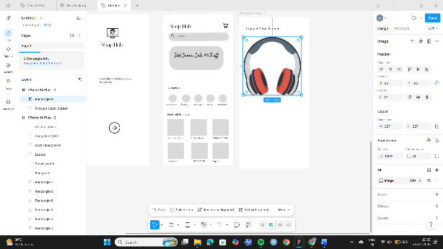
Step 13. Rectangles are styled by adjusting the corner radius to give rounded edges for a modern UI look.
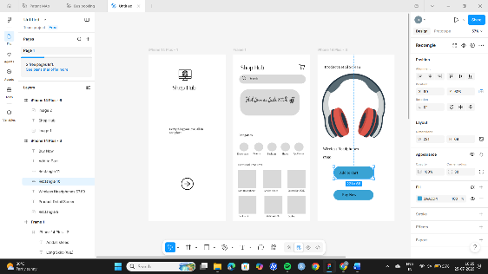
Step 14. A new frame is selected and filled with text and icons to represent another page of the app.
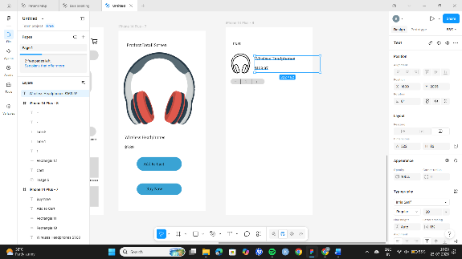

Step 15. Add text by selecting T
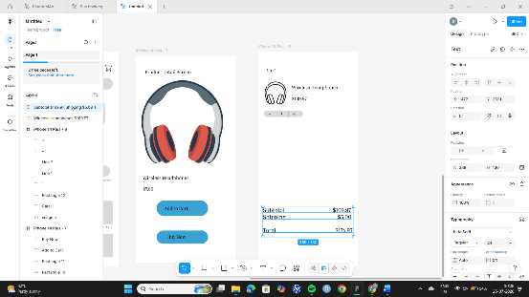
Step 16: Adjusting Rectangle Radius
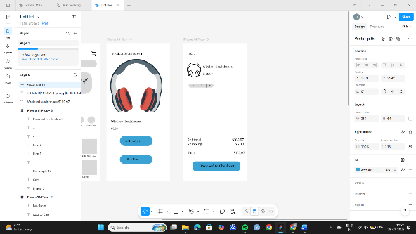
Step 17. All screens are connected using the Prototype tool in Figma by dragging connections between frames to simulate navigation.

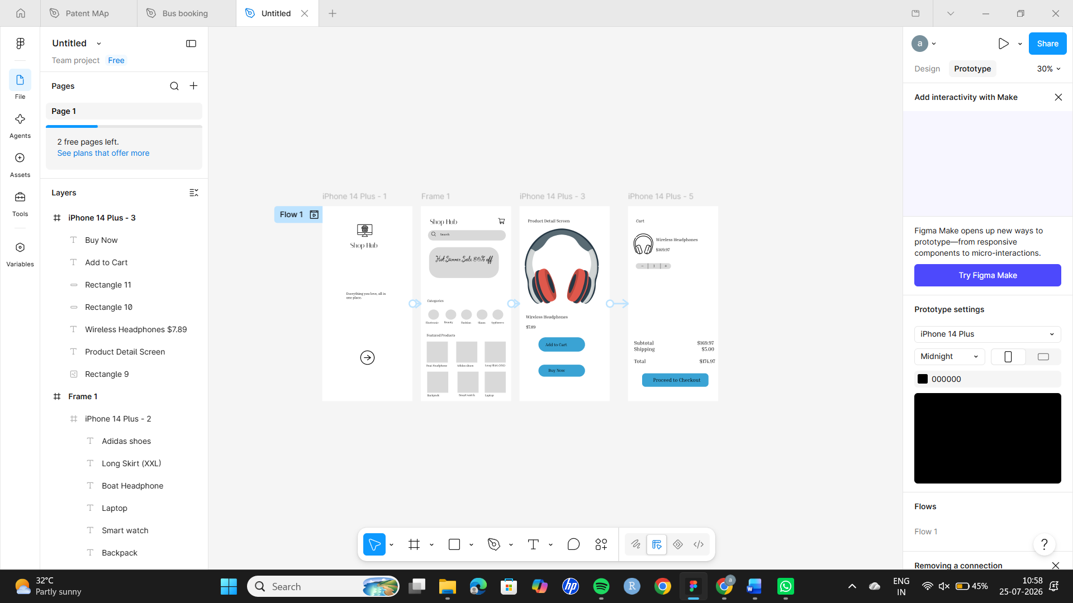
OUTPUT: A complete interactive prototype of an E-Commerce mobile application is successfully created using Figma and is ready for stakeholder review.

